Name : Wilbert Chandra
NIM : 2602113666
Class : LB-09
- Quartile and Five Number Summary
 | Money Market | One-Year Deposit | Five-Year Deposit
Minimum | 0,01 | 0,25 | 1,00
Q1 | 0,2 | 1,35 | 1,7
Q2 / Median | 0,75 | 2 | 3
Q3 | 1,75 | 2,05 | 3,3
IQR | 1,55 | 0,7 | 1,6
Maximum | 2,12 | 2,30 | 3,70

BoxPlot

From the boxplot above we can see that the blue representing “Money Market”, Orange representing “One-year Deposit”, and Grey representing “Five-Year Deposit”. From the chart above we can see the yield increases from money market in the lowest to five-year deposit in the highest.
- Calculate
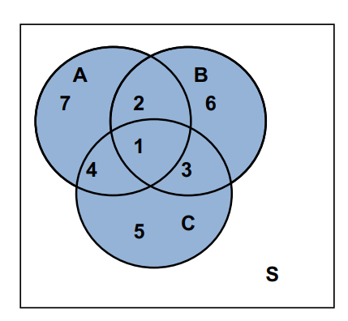
  - A ∩ B = {1, 2}
  - B ∩ C = {1, 3}
  - A ∪ C = {1, 2, 3, 4, 5, 7}
  - A ∩ B` = {4, 7}
  - A ∩ B ∩ C = {1}
  - (A ∩ B) ∩ C` = {1, 2, 3, 4, 6, 7} ∩ {2, 6, 7} = {2, 6, 7}

- Answer
  - Event of selecting a male / female / person who felt tensed or out of work.
  - Event of selecting a person and a male that felt tensed or out of work.
  - A Complement is an event with all the elements except the one in the particular subset. So the complement of “Felt tense or stressed out at work” is the event of “Not Felt tense or stressed out at work”.
  - Yes. Being a male and “Feeling tense or stressed out at work” is not a mutually exclusive event because there’s a joint event of being a male and “Feeling tense or stressed out at work”.
  - $\frac{244}{526}=0.463$
  - $\frac{244}{739}=0.330$
  - The difference between the result in (e) and (f) is that the (e) uses the total of the people who are “Feeling tense or stressed out at work” as the divider and the (f) uses the total amount of male as the divider. This was done because the difference of the priority from the question.
  - No, it’s not independent.

- Answer
  - Probability of On time = 0.77
  - Probability of Satisfactory = 0.85
  - Probability of Satisfactory and On time = $0.77*0.85= 0.6545$

- Answer
  - Expected Amount of withdrawal :
$$E\left(X\right)= 20 * 0.3 = 6$$
  - Exactly 3 students withdraw :
$$P\left(X = 3\right)=\frac{20!}{3!\left(20-3\right)!} * {0.3}^{3} * {0.7}^{17}≈ 0.00125.$$
  - More than 3 students withdraw :
$$P\left(X > 3\right)= 1 - P\left(X ≤ 3\right)= 1 - \left[P\left(X = 0\right)+ P\left(X = 1\right)+ P\left(X = 2\right)+ P\left(X = 3\right)\right]=1 -\left[\left(\frac{20!}{0!\left(20-0\right)!} * {0.3}^{0} * {0.7}^{20}\right)+ \left(\frac{20!}{1!\left(20-1\right)!} * {0.3}^{1} * {0.7}^{19}\right)+ \left(\frac{20!}{2!\left(20-2\right)!} * {0.3}^{2} * {0.7}^{18}\right)+ \left(\frac{20!}{3!\left(20-3\right)!} * {0.3}^{3} * {0.7}^{17}\right)\right] ≈ 0.8929.$$
- Answer (λ = 48 / 12 = 4)
  - $P\left(3\right)=\frac{e^{-4} * 4^{3}}{3!} ≈ 0.1953$
  - $P\left(X<3\right)=P\left(0\right)+P\left(1\right)+P\left(2\right)= \frac{e^{-4} * 4^{0}}{0!}+ \frac{e^{-4} * 4^{1}}{1!}+ \frac{e^{-4} * 4^{2}}{2!} ≈ 0.2381$
  - $P\left(X>3\right)=1-\left[P\left(3\right)+P\left(X<3\right)\right]=1-\left[0.1953+0.2381\right] ≈ 0.5665$
  - $λ=\frac{48}{4}=12→P\left(10\right)=\frac{e^{-12} * {12}^{10}}{10!}=0.1048$

